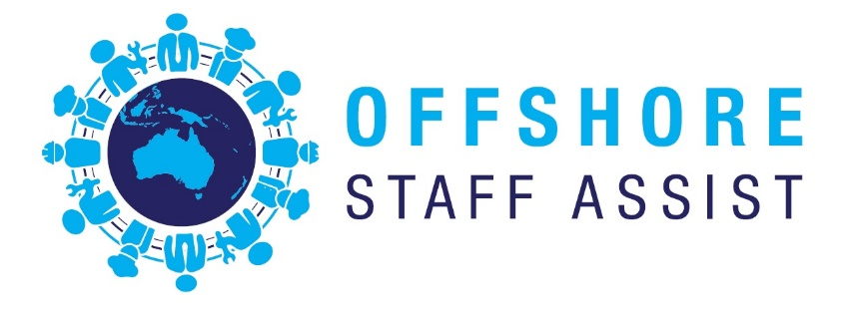 **Home Who We Are What We Do Upload Resume Contact Us Gallery**

***Offshore Staff Assist*** is a specialist foreign worker recruitment consultancy company that prides itself on exceptional account management, service delivery and client satisfaction. ***Offshore Staff Assist*** has been newly formed to bring together some of the offshore recruitment industry’s most expert recruitment consultants who have many years’ experience of providing tailored, professional recruitment solutions and have succeeded in winning preferred supplier status with clients internationally.

***Offshore Staff Assist*** specialises in the placement of candidates in permanent, contract and temporary positions, tailored to your needs and have established networks Indonesia, Malaysia, Philippines, Africa, Singapore as well as traditional markets including the United Kingdom, Canada, America and Ireland.

**How We Assist You Find the Best Candidates**

The role of a recruitment consultancy is to act as an intermediary in identifying and sourcing suitably qualified candidates for both permanent or temporary/contract positions.

***Offshore Staff Assist*** is about matching your needs to the availability of expertise and experience of personnel worldwide. It is about sourcing the right people for your requirements – and doing it right, every time.

We maintain an existing data base of screened applicants with the use of our worldwide affiliated agents as we recognise the difficulties employers experience in sourcing the right staff: advertising without results, accessing pool or floating workers who have no loyalty and the expense of filling positions with short term staff from labour hire companies.

The knowledge and expertise in the legal recruitment of overseas staff is also of major importance to us and our client’s. ***Offshore Staff Assist*** has interment knowledge of all legal requirements necessary to recruit from international locations and therefore can guarantee that all legal requirements are fulfilled at no risk to your company.

**Overseas Staffing Recruitment**

* Relations with recruitment agencies over the world who have home-grown networks to assist our client in their staffing needs.
* Understanding of the local demands and legal requirements which let us be at the forefront of recruiting offshore personnel.
* Reputable recruitment agency that provides international recruitment with knowledge in your company’s explicit needs.
* International workforce solutions provider in mining, infrastructure, hospitality, Metal Fabrication, Automotive industries and others

**Tailored Recruitment**

* Unique Job Position Vacancies can be sources from anywhere in the world
* White Collar Head Hunting
* Clients can choose specific individualised services

**International Recruitment Consulting**

* 407 Training Plan
* Long term strategic overseas Recruitment Plan
* Liaison with Migration Agents for clients to ensure compliance